DATA SCIENCE TOOLBOX: PYTHON PROGRAMMING PROJECT REPORT
(Project Semester January-April 2025)

PATIENT HEALTH DETERIORATION ANALYSIS
USING PYTHON

Submitted by
Krishika Malhotra
Registration No: 12413944

Programme and Section : 4M029
Course Code : INT 375

Under the Guidance of
Dr. Savleen Kaur
Discipline of CSE/IT
Lovely School of Computer Science
Lovely Professional University, Phagwara



CERTIFICATE

This is to certify that Krishika Malhotra bearing Registration no. 12413944 has completed INT 375 project titled, “Patient Health Deterioration Analysis using Python” under my guidance and supervision. To the best of my knowledge, the present work is the result of his/her original development, effort and study.

Signature and Name of the Supervisor
Designation of the Supervisor
School of Computer Science
Lovely Professional University
Phagwara, Punjab.

Date: April 22, 2026

DECLARATION

I, Krishika Malhotra, student of Bachelor of Technology under CSE/IT Discipline at, Lovely Professional University, Punjab, hereby declare that all the information furnished in this project report is based on my own intensive work and is genuine.

Date: April 22, 2026 Name: Krishika Malhotra
Registration No.: 12413944

TABLE OF CONTENTS

Table of Contents
S. No. | Title | Page No.
1 | Introduction | 5
2 | Scope of the Analysis | 8
3 | Existing System | 10
4 | Dataset Description | 13
5 | ETL Process | 16
6 | Analysis on Dataset | 19
7 | Results and Findings | 25
8 | Future Scope | 28
9 | Conclusion | 30
10 | References | 32
11 | Bibliography | 32

INTRODUCTION

In recent years, the healthcare industry has undergone a significant transformation with the increasing adoption of data-driven technologies. Hospitals and medical institutions generate vast amounts of patient data on a daily basis, including vital signs, laboratory results, and clinical observations. Effectively analyzing this data is crucial for improving patient outcomes, enhancing clinical decision-making, and reducing the risk of critical health events.

One of the most important challenges in modern healthcare is the early detection of patient deterioration. Patient deterioration refers to a gradual or sudden decline in a patient’s physiological condition, which may lead to severe complications if not identified and addressed in a timely manner. Early detection plays a vital role in preventing adverse outcomes such as organ failure, sepsis, or even death. However, monitoring patient conditions manually is often difficult due to the continuous and complex nature of medical data.

With the advancement of data science and analytical tools, it has become possible to process and analyze large volumes of healthcare data efficiently. Techniques such as data preprocessing, exploratory data analysis (EDA), and visualization enable healthcare professionals and analysts to uncover patterns, trends, and anomalies within patient data. These insights can be used to identify early warning signs and support proactive medical interventions.

This project focuses on analyzing patient health data using Python, a widely used programming language in the field of data science. The dataset used in this study contains hourly records of patient vitals collected during hospital admissions. It includes important health indicators such as heart rate, respiratory rate, oxygen saturation (SpO₂), temperature, blood pressure, and various laboratory parameters. Additionally, the dataset includes a deterioration event variable, which indicates whether a patient experienced a decline in their condition.

The primary aim of this project is to perform a comprehensive analysis of patient health data to understand how vital signs change over time and how they relate to patient deterioration. This is achieved through a systematic approach that includes data extraction, cleaning, transformation, and exploratory data analysis. By visualizing the data using graphs such as line plots, histograms, heatmaps, and boxplots, complex information is transformed into an easily interpretable format.

Another key objective of this project is to identify relationships between different health metrics. For example, variations in heart rate, oxygen levels, and respiratory rate may provide valuable insights into a patient’s condition. By studying these relationships, it becomes possible to detect patterns that are associated with deterioration events.

Furthermore, this project highlights the importance of data cleaning and preprocessing in healthcare analytics. Real-world datasets often contain missing values, inconsistencies, and noise, which can affect the accuracy of analysis. Therefore, appropriate techniques are applied to ensure that the dataset is reliable and suitable for analysis.

In addition to exploratory analysis, the project also demonstrates how basic analytical techniques can be applied to healthcare data to derive meaningful insights. While advanced machine learning models are not the primary focus, the foundation established in this project can be extended to predictive analytics and real-time monitoring systems in the future.

The significance of this project lies in its practical application. By analyzing patient health data and identifying patterns associated with deterioration, healthcare providers can take timely action and improve patient care. The insights gained from this analysis can contribute to better monitoring systems, improved clinical decision-making, and enhanced patient safety.

In conclusion, this project demonstrates how data science techniques can be effectively applied in the healthcare domain to analyze patient data and detect early signs of deterioration. It emphasizes the role of technology in modern medicine and showcases the potential of data-driven approaches in improving healthcare outcomes.

OBJECTIVES

The primary objective of this project is to analyze patient health data using Python-based data science techniques in order to identify patterns, trends, and indicators associated with patient deterioration. The project aims to transform raw healthcare data into meaningful insights that can support better understanding of patient conditions and improve decision-making processes in clinical environments.

One of the key objectives is to study the variation of vital signs over time. The dataset contains hourly records of patient health metrics such as heart rate, respiratory rate, oxygen saturation (SpO₂), and temperature. By analyzing these variables over the duration of hospital admission, the project aims to understand how patient conditions evolve and whether any noticeable patterns emerge prior to deterioration events.

Another important objective is to identify relationships between different health indicators. In real-world healthcare scenarios, patient conditions are rarely dependent on a single factor. Instead, multiple physiological parameters interact with each other. This project aims to examine these relationships through correlation analysis and visualization techniques, helping to uncover how different variables influence each other.

The project also focuses on detecting abnormal patterns and outliers within the dataset. Sudden spikes or drops in vital signs can indicate critical changes in patient health. By using graphical tools such as box plots and histograms, the analysis aims to identify such anomalies and understand their significance in the context of patient deterioration.

Data cleaning and preprocessing form another crucial objective of this project. Real-world healthcare datasets often contain missing values, inconsistencies, and noise, which can impact the accuracy of analysis. Therefore, appropriate data cleaning techniques are applied to ensure that the dataset is reliable and suitable for further processing.

In addition, the project aims to perform exploratory data analysis (EDA) using various visualization techniques. Graphical representations such as line plots, histograms, and heatmaps are used to present data in an intuitive and easily understandable manner. These visualizations help in identifying trends and patterns that may not be immediately visible in raw data.

Another objective is to analyze the occurrence of deterioration events and understand how they relate to different health metrics. By comparing data points where deterioration occurs with normal conditions, the project aims to identify potential early warning signs that can help in predicting such events.

The project also seeks to demonstrate the application of Python libraries such as pandas, matplotlib, and seaborn in healthcare data analysis. These tools provide efficient methods for data manipulation, visualization, and analysis, making them essential for modern data science workflows.

Furthermore, the project aims to build a strong foundation for future enhancements such as predictive modeling and real-time monitoring systems. While the current scope focuses on exploratory analysis, the insights gained can be extended to develop advanced machine learning models for predicting patient deterioration.

Finally, the overall objective of this project is to highlight the importance of data-driven approaches in healthcare. By leveraging data science techniques, it becomes possible to gain deeper insights into patient conditions, improve monitoring systems, and ultimately enhance the quality of healthcare services.

DATASET DESCRIPTION

The dataset used in this project is a healthcare time-series dataset that contains detailed information about patient vital signs recorded at regular intervals during hospital admission. It is designed to monitor patient conditions over time and identify potential signs of deterioration based on physiological and clinical parameters.

The dataset is structured in a tabular format, where each row represents a recorded observation for a patient at a specific point in time. The presence of a time-based variable allows the dataset to capture the progression of a patient’s condition, making it suitable for time-series analysis.

3.1 Nature of the Dataset
The dataset is a combination of numerical and categorical variables, primarily focused on physiological measurements. It is considered a real-world dataset as it simulates actual hospital monitoring data, which often includes irregularities such as missing values and noise.

The time-series nature of the dataset enables continuous tracking of patient health metrics, allowing for analysis of trends and patterns over time rather than at a single point.

3.2 Key Features of the Dataset
The dataset includes several important features that are critical for analyzing patient health conditions:
- patient_id: A unique identifier assigned to each patient. This helps in distinguishing between different patients in the dataset.
- hour_from_admission: Represents the number of hours since the patient was admitted to the hospital. This serves as a time variable and is essential for analyzing how patient conditions change over time.
- heart_rate: Measures the number of heartbeats per minute. It is a key indicator of cardiovascular health and can reflect stress, illness, or physical condition.

- respiratory_rate: Indicates the number of breaths taken per minute. Abnormal respiratory rates can signal respiratory distress or other medical conditions.
- spo2_pct (Oxygen Saturation): Represents the percentage of oxygen in the patient’s blood. Lower values may indicate breathing difficulties or poor oxygen supply.
- temperature_c: Records the body temperature in degrees Celsius. Elevated temperatures may indicate infection or inflammation.
- systolic_bp and diastolic_bp: Represent blood pressure readings. These are important indicators of cardiovascular health.
- wbc_count (White Blood Cell Count): Used to detect infections or immune system activity.
- lactate: Indicates the level of lactic acid in the blood, which can signal poor oxygenation or metabolic stress.
- creatinine: Reflects kidney function and helps identify potential kidney-related issues.
- crp_level (C-reactive Protein): A marker of inflammation in the body.
- hemoglobin: Measures the oxygen-carrying capacity of blood.
- sepsis_risk_score: Provides an estimate of the likelihood of sepsis, a serious medical condition caused by infection.
- deterioration_event: A binary variable indicating whether a patient experienced deterioration. This is one of the most important variables in the dataset, as it helps in identifying patterns associated with declining health.

3.3 Size and Structure of the Dataset
The dataset consists of a large number of observations recorded over multiple time intervals. Each patient may have multiple entries corresponding to different hours from admission. This structure allows for detailed tracking of patient health over time.

The dataset is well-suited for exploratory data analysis as well as time-series analysis due to its structured format and variety of variables.

3.4 Importance of the Dataset
This dataset is highly valuable for healthcare analysis as it enables:
- Monitoring of patient conditions over time
- Identification of early warning signs of deterioration
- Analysis of relationships between different health indicators
- Detection of abnormal patterns and anomalies

By studying this dataset, it becomes possible to gain insights that can improve patient monitoring systems and support timely medical interventions.

3.5 Challenges in the Dataset
Like most real-world datasets, this dataset presents several challenges:
- Missing Values: Some observations may have incomplete data
- Data Noise: Variability in measurements may introduce noise
- Large Size: Handling large datasets requires efficient processing
- Outliers: Extreme values may affect analysis

These challenges are addressed through data cleaning and preprocessing techniques during the ETL process.

3.6 Conclusion of Dataset Description
In conclusion, the dataset provides a comprehensive view of patient health metrics over time. Its detailed structure and variety of features make it suitable for analyzing patterns related to patient deterioration and extracting meaningful insights using data science techniques.

SCOPE OF THIS PROJECT

The scope of this project encompasses a comprehensive analysis of air pollution data using Python-based data science techniques. The primary aim is to explore, analyze, and interpret pollution data in order to extract meaningful insights that can contribute to a better understanding of environmental conditions.

This project begins with a detailed examination of the dataset structure. Understanding the dataset is a crucial first step, as it provides clarity on the type of data available, the variables involved, and the relationships between them. The dataset includes multiple attributes such as city, state, pollutant type, and pollution levels, which form the foundation of the analysis.

A significant portion of the project is dedicated to data cleaning and preprocessing. Real-world datasets often contain missing values, inconsistencies, and errors that can affect the accuracy of analysis. Therefore, appropriate techniques are applied to handle missing data, standardize formats, and ensure that the dataset is suitable for further processing. This step is essential to maintain the reliability and validity of the results.

Exploratory Data Analysis (EDA) forms the core component of the project. Through EDA, various patterns, trends, and relationships within the dataset are identified. The analysis includes examining how pollution levels vary across different cities and states, understanding the behavior of different pollutants, and studying changes in pollution over time. This process helps in uncovering hidden insights that are not immediately apparent.

Visualization plays a crucial role in this analysis. Graphical representations such as bar charts, line plots, histograms, and box plots are used extensively to present data in an understandable format. These visualizations not only enhance clarity but also make it easier to communicate findings effectively. Each visualization is accompanied by a detailed explanation to ensure proper interpretation.

The project also includes a comparative analysis of pollution levels. By comparing data across different regions and pollutants, it becomes possible to identify patterns such as which cities are most affected, which pollutants are dominant, and how pollution varies geographically. This comparative approach adds depth to the analysis and provides a broader perspective.

Basic statistical techniques are applied to summarize the dataset and understand its characteristics. Measures such as mean, median, minimum, maximum, and distribution patterns are analyzed to gain insights into the overall behavior of pollution levels. Additionally, correlation analysis is performed to examine relationships between variables.

A simple predictive model is also implemented as part of the project. Although the primary focus is on analysis, the inclusion of a regression model demonstrates how machine learning techniques can be applied to environmental data. This model provides an estimate of pollution levels based on available features, showcasing the potential for predictive analytics in this domain.

It is important to note that the scope of this project is limited to descriptive and exploratory analysis. Advanced machine learning techniques, real-time data integration, and large-scale deployment are beyond the scope of this study. However, the project lays a strong foundation for future enhancements in these areas.

In conclusion, the scope of this project is designed to provide a comprehensive understanding of air pollution data through systematic analysis and visualization. It highlights the importance of data-driven approaches in environmental studies and demonstrates how analytical tools can be used to derive meaningful insights from complex datasets.

EXISTING SYSTEM

3.1 Overview of the Existing System
Air pollution monitoring has traditionally relied on conventional methods such as manual data collection, fixed monitoring stations, and periodic reporting by environmental agencies. These systems are designed to measure pollutant concentrations in the atmosphere and provide basic information regarding air quality levels in specific regions.

Government organizations and environmental bodies deploy monitoring stations in selected locations to collect data on pollutants such as particulate matter, nitrogen dioxide, sulfur dioxide, and carbon monoxide. This data is typically recorded at regular intervals and stored in centralized databases. Reports are then generated periodically, which are used for policy-making and public awareness.

While these systems play a crucial role in tracking pollution levels, they are often limited in terms of analytical capabilities. The data collected is usually presented in raw or summarized formats, without extensive analysis or interpretation. As a result, it becomes difficult to extract deeper insights or identify complex patterns within the data.

Moreover, traditional systems are largely reactive rather than proactive. They focus on reporting existing pollution levels instead of predicting future trends or providing actionable recommendations. This limits their effectiveness in addressing the growing challenges of air pollution.

3.2 Limitations of the Existing System
Despite their importance, traditional air pollution monitoring systems suffer from several significant limitations:

1. Time-Consuming Process
The process of collecting, storing, and analyzing pollution data manually can be slow and inefficient. Generating reports often requires significant time, which delays decision-making.
2. Lack of Real-Time Insights
Most traditional systems do not provide real-time analysis or instant feedback. This makes it difficult to respond quickly to sudden increases in pollution levels.
3. Limited Data Analysis
The existing systems primarily focus on data collection rather than data analysis. Advanced analytical techniques such as trend detection, correlation analysis, and predictive 16odelling are often not utilized.
4. Poor Visualization
Data is usually presented in tabular or textual formats, which can be difficult to interpret. The absence of effective visualizations limits the ability to understand patterns and relationships within the data.
5. Difficulty in Identifying Patterns
Without proper analytical tools, it is challenging to identify hidden patterns, seasonal trends, or anomalies in pollution data.
6. Lack of Predictive Capability
Traditional systems do not incorporate machine learning or predictive models. As a result, they are unable to forecast future pollution levels or provide early warnings.
7. Inability to Handle Large Datasets Efficiently
With the increasing volume of environmental data, manual methods struggle to process and analyze large datasets effectively.
8. Limited Comparative Analysis
Comparing pollution levels across different cities, states, or pollutants is difficult without automated analytical tools.

3.3 Need for the Proposed System
The limitations of the existing system highlight the need for a more advanced and efficient approach to air pollution analysis. A data-driven system using Python and modern data science techniques can overcome these challenges by:
- Automating data cleaning and preprocessing
- Providing interactive and insightful visualizations
- Enabling advanced statistical analysis
- Identifying patterns and trends efficiently
- Supporting predictive modelling

The proposed system addresses these gaps by leveraging programming and analytical tools to transform raw data into meaningful insights. This approach not only improves efficiency but also enhances the accuracy and usability of the analysis.

In summary, the transition from traditional methods to data-driven analysis represents a significant advancement in the field of environmental monitoring. It enables better understanding, faster decision-making, and more effective management of air pollution.

PROBLEM STATEMENT

In modern healthcare environments, hospitals continuously generate vast amounts of patient data through monitoring systems, electronic health records, and diagnostic tools. This data includes critical physiological parameters such as heart rate, oxygen saturation, respiratory rate, blood pressure, and various laboratory measurements. While this information is extremely valuable, the challenge lies in effectively analyzing and interpreting it in real time to detect early signs of patient deterioration.

Due to the sheer volume and complexity of the data, healthcare professionals often rely on manual observation and threshold-based monitoring systems, which are not always sufficient to capture subtle patterns or gradual changes in patient condition.

As a result, early warning signs of deterioration may go unnoticed, leading to delayed interventions, increased risk of complications, prolonged hospital stays, and in severe cases, mortality. Another major issue is that traditional monitoring systems are designed to react to extreme values rather than predict future risks. These systems generate alerts only when a specific parameter crosses a predefined limit, ignoring the relationships between multiple variables and the overall trend of a patient’s health over time.

This reactive approach limits the ability to identify deterioration at an early stage, when preventive measures could be most effective. Additionally, the lack of proper data visualization and analytical tools makes it difficult to extract meaningful insights from raw data, further reducing the efficiency of patient monitoring systems.

Therefore, there is a clear need for a data-driven approach that can analyze patient health data systematically, identify hidden patterns, detect anomalies, and provide meaningful insights. By applying data science techniques such as data cleaning, exploratory data analysis, and visualization, it becomes possible to transform raw healthcare data into actionable information.

This project addresses the problem by utilizing Python-based analytical tools to study patient vital signs, understand trends over time, and identify indicators associated with deterioration events, ultimately contributing to improved patient monitoring and healthcare outcomes.

SCOPE OF THE PROJECT

The scope of this project is centered around the comprehensive analysis of patient health data using Python-based data science techniques, with the primary objective of understanding patterns, trends, and relationships associated with patient deterioration. This project focuses on working with a structured, time-series healthcare dataset that records patient vital signs at regular hourly intervals during hospital admission. The presence of a temporal variable, namely hour_from_admission, enables a detailed examination of how patient conditions evolve over time, allowing for a dynamic and continuous analysis rather than a static snapshot of health metrics.

A significant portion of the project is dedicated to data preprocessing and cleaning, which forms the foundation of any reliable data analysis process. Real-world healthcare datasets are often incomplete and may contain missing values, inconsistencies, duplicate entries, and noise. Therefore, the scope includes applying appropriate data cleaning techniques such as handling missing values using forward filling methods, removing duplicate records, verifying data types, and organizing the dataset in a structured format. These steps ensure that the dataset is accurate, consistent, and suitable for further analysis.

The project also extensively covers exploratory data analysis (EDA), which plays a crucial role in uncovering hidden patterns and insights within the dataset. Various visualization techniques are employed to analyze the behavior of key health indicators such as heart rate, oxygen saturation (SpO₂), respiratory rate, temperature, and blood pressure. Line plots are used to study time-based trends, histograms help in understanding the distribution of variables, and boxplots are utilized to detect outliers and abnormal values. Additionally, correlation analysis is performed to examine the relationships between different physiological parameters, providing a deeper understanding of how these variables interact with each other.

Another important aspect of the project scope is the analysis of the deterioration_event variable, which indicates whether a patient’s condition has worsened. By comparing the values of different health metrics during normal conditions and deterioration events, the project aims to identify patterns and early warning signals that may indicate a decline in patient health. This comparative analysis helps in understanding the factors that contribute to deterioration and highlights the importance of continuous monitoring.

Furthermore, the project aims to present the findings in a clear and interpretable manner through well-structured visualizations and detailed explanations. The inclusion of graphical representations enhances the readability of the analysis and allows for better communication of insights. The project also demonstrates the practical application of Python libraries such as pandas, matplotlib, and seaborn in handling and analyzing healthcare data.

It is important to note that the scope of this project is limited to exploratory and descriptive analysis. While the dataset provides opportunities for advanced machine learning applications, such as predictive modeling and risk forecasting, these are beyond the current scope. However, the analysis performed in this project lays a strong foundation for future enhancements, including the development of predictive models, real-time monitoring systems, and intelligent healthcare applications.

In conclusion, the scope of this project encompasses the complete process of transforming raw patient health data into meaningful insights through data cleaning, exploratory analysis, and visualization. It highlights the potential of data science in improving healthcare systems by enabling better understanding of patient conditions and supporting early detection of deterioration.

EXISTING SYSTEM

In traditional healthcare environments, patient monitoring systems are primarily based on manual observation and basic electronic monitoring devices that track vital signs such as heart rate, blood pressure, respiratory rate, and oxygen saturation. These systems are designed to provide real-time readings of individual physiological parameters and generate alerts when certain predefined thresholds are exceeded. While such systems play a crucial role in ensuring patient safety, they are inherently limited in their ability to perform comprehensive data analysis and detect complex patterns associated with patient deterioration.

The existing system operates on a reactive approach, where alerts are triggered only after a parameter crosses a critical limit. This means that early warning signs, which may manifest as gradual changes or subtle variations in multiple parameters, are often overlooked. For instance, a slight but consistent increase in heart rate combined with a minor drop in oxygen saturation may indicate an emerging health issue, but traditional systems may not recognize this pattern because each parameter individually remains within acceptable limits. As a result, critical conditions may go undetected until they reach a severe stage, reducing the effectiveness of timely medical intervention.

Another limitation of the existing system is its inability to analyze multiple variables simultaneously. Patient health is influenced by a combination of factors, and understanding the relationships between different physiological parameters is essential for accurate assessment. However, conventional monitoring systems typically evaluate each parameter independently, without considering their interdependencies. This lack of integrated analysis restricts the system’s ability to provide a holistic view of patient condition.

Furthermore, traditional systems often lack advanced data visualization capabilities. The data collected is usually presented in the form of numerical readings or basic charts, which may not effectively convey trends, patterns, or anomalies. This makes it difficult for healthcare professionals to quickly interpret the data and identify potential issues. The absence of intuitive and interactive visualizations limits the usability of the system and increases the cognitive load on medical staff.

In addition, the growing volume of healthcare data presents a significant challenge for existing systems. Hospitals generate large amounts of patient data continuously, and manual analysis of such data is both time-consuming and prone to human error. Without automated analytical tools, it becomes difficult to process and interpret this data efficiently. Important insights may remain hidden, and opportunities for early intervention may be missed.

The lack of predictive capabilities is another major drawback of the existing system. Traditional monitoring approaches focus on current conditions rather than forecasting future risks. They do not utilize historical data to identify trends or predict potential deterioration, which limits their ability to support proactive healthcare management. In modern medical practice, there is an increasing need for systems that can not only monitor but also predict patient outcomes.

Moreover, issues such as missing data, noise, and inconsistencies further complicate the analysis process. Existing systems are not equipped with advanced data cleaning and preprocessing techniques, which can lead to inaccurate or misleading results. This highlights the need for more robust data handling methods.

In summary, while traditional patient monitoring systems provide essential real-time data, they are limited by their reactive nature, lack of advanced analytical capabilities, poor visualization, and inability to handle large datasets effectively. These limitations create a strong need for a more sophisticated, data-driven approach that can analyze patient data comprehensively, identify patterns, and support early detection of deterioration. This project addresses these challenges by leveraging data science techniques to enhance the analysis and interpretation of healthcare data.

SOURCE OF DATASET

The dataset utilized in this project has been obtained from publicly available healthcare data repositories and is designed to represent patient monitoring data collected in a clinical environment. Such datasets are commonly used in academic research, data science projects, and healthcare analytics studies to simulate real-world medical scenarios while maintaining patient privacy through anonymization. The data reflects the type of information typically recorded in hospitals during patient admission, where vital signs and laboratory parameters are continuously monitored and documented at regular intervals.

The dataset is structured in a tabular format and stored as a Comma-Separated Values (CSV) file, which allows for efficient storage, retrieval, and processing using programming tools such as Python. Each record in the dataset corresponds to a specific observation of a patient at a given point in time, enabling detailed tracking of patient conditions throughout their hospital stay. The presence of multiple observations per patient makes the dataset particularly suitable for time-series analysis, as it captures the progression of physiological changes over time.

The data includes a wide range of features that represent different aspects of patient health. These features encompass vital signs such as heart rate, respiratory rate, oxygen saturation, temperature, and blood pressure, as well as laboratory indicators such as white blood cell count, lactate levels, creatinine, and inflammation markers. Additionally, the dataset includes derived variables such as the sepsis risk score and a deterioration event indicator, which provide valuable insights into patient condition and risk levels.

One of the key characteristics of the dataset is the inclusion of the variable hour_from_admission, which represents the time elapsed since the patient was admitted to the hospital. This variable serves as a temporal dimension, allowing for the analysis of trends and patterns in patient health over time. Unlike traditional datasets that provide only static information, this time-based structure enables a more dynamic and comprehensive analysis.

Although the dataset may be simulated or anonymized, it closely mirrors real-world clinical data in terms of structure, variability, and complexity. This makes it highly relevant for educational purposes and practical applications in healthcare analytics. The dataset may contain typical challenges associated with real-world data, such as missing values, inconsistencies, and noise, which further enhances its suitability for demonstrating data cleaning and preprocessing techniques.

The dataset was imported into the Python environment using the pandas library, which provides powerful tools for data manipulation and analysis. Once loaded, the data was examined, cleaned, and prepared for further processing, ensuring that it was suitable for exploratory data analysis and visualization.

In conclusion, the dataset serves as a reliable and comprehensive foundation for this project. Its rich set of features, time-series structure, and realistic representation of patient health data make it an ideal resource for analyzing patterns of patient deterioration and demonstrating the application of data science techniques in the healthcare domain.

ETL PROCESS

The ETL (Extract, Transform, Load) process is a fundamental component of data analysis and plays a crucial role in ensuring that raw data is converted into a clean, structured, and usable format. In the context of this project, the ETL process was applied to the healthcare dataset to prepare it for exploratory data analysis and visualization. Given that real-world datasets often contain inconsistencies, missing values, and irregularities, the ETL process becomes essential for maintaining the accuracy and reliability of the analysis.

The first stage of the ETL process is data extraction, which involves loading the dataset from its source into the working environment. In this project, the dataset was stored in a CSV (Comma-Separated Values) file format and was imported into Python using the pandas library. Pandas provides efficient methods for reading structured data and converting it into a DataFrame, which allows for easy manipulation and analysis. The extraction process ensures that the dataset is successfully loaded and accessible for further processing.

The second stage is data transformation, which is the most critical and time-consuming part of the ETL process. This stage involves cleaning and preparing the data to ensure its quality and consistency. One of the primary tasks performed during transformation was the removal of duplicate records. Duplicate entries can lead to biased results and incorrect interpretations, so they were identified and eliminated to maintain data integrity.

Another important step in the transformation process was handling missing values. Healthcare datasets often contain incomplete information due to various reasons such as sensor errors or data recording issues. In this project, missing values were handled using a forward fill method, where missing entries are replaced with the last available valid observation. This approach is particularly suitable for time-series data, as it preserves the continuity of the dataset and avoids abrupt gaps in the analysis.

The dataset was then sorted based on the variable hour_from_admission, which represents the time elapsed since patient admission. Sorting the data in chronological order is essential for analyzing trends and patterns over time. Without proper ordering, time-based analysis would produce inaccurate results and misleading interpretations.

In addition to these steps, data types were verified and corrected where necessary to ensure compatibility with analytical functions. Numerical columns were checked for consistency, and any discrepancies were addressed to prevent errors during computation. This step ensures that mathematical operations and visualizations can be performed accurately.

Another key aspect of the transformation process was filtering and organizing relevant columns. While the dataset contains multiple variables, only those relevant to the analysis were emphasized, such as heart rate, oxygen saturation, respiratory rate, and deterioration indicators. This helps in reducing complexity and improving the efficiency of analysis.

The final stage of the ETL process is data loading, where the cleaned and transformed dataset is prepared for analysis. In this project, the processed data remained within the pandas DataFrame, which served as the primary structure for performing exploratory data analysis and visualization. The cleaned dataset was then used to generate graphs, perform statistical analysis, and derive insights.

The ETL process is of great importance as it directly impacts the quality of the results obtained from the analysis. Poorly cleaned data can lead to incorrect conclusions, while a well-processed dataset ensures accurate and meaningful insights. By carefully executing each stage of the ETL process, this project establishes a strong foundation for reliable and effective data analysis.

In conclusion, the ETL process in this project transforms raw healthcare data into a structured and analysis-ready format. It ensures data quality, consistency, and reliability, thereby enabling accurate exploration of patterns related to patient health and deterioration.

ANALYSIS ON DATASET

The analysis of this comprehensive healthcare dataset was meticulously executed using advanced Exploratory Data Analysis (EDA) techniques, specifically tailored to decode the intricate physiological behaviors, temporal fluctuations, and latent relationships embedded within longitudinal patient records. Given that the data is characterized by high-frequency, time-series observations, the primary analytical focus was shifted toward a dynamic understanding of patient health.

Rather than viewing health as a static snapshot, this methodology allowed us to observe the continuous evolution of physiological parameters from the moment of admission. By doing so, the analysis seeks to identify the subtle precursors and specific "signature" patterns—such as the gradual erosion of vital stability—that serve as critical early warning signs before a patient reaches a state of clinical deterioration.

Functioning as a robust, multidimensional health profile, the dataset integrates a diverse array of metrics to create a holistic view of the patient’s internal state. This includes continuous vital signs—such as heart rate, peripheral oxygen saturation (SpO₂), respiratory rate, core body temperature, and arterial blood pressure—which provide a real-time window into the autonomic nervous system and cardiovascular stability.

These are further enriched by intermittent laboratory markers, including White Blood Cell (WBC) counts, lactate levels, and creatinine, which offer deeper insights into systemic inflammation, metabolic distress, and organ function. By rigorously examining these variables through four distinct analytical lenses—longitudinal trends, frequency distributions, statistical variability, and multivariate correlations—we effectively transform raw, disparate data points into a coherent, actionable clinical narrative. This approach ensures that the resulting dashboard is not merely a reporting tool, but a predictive framework designed to support data-driven decision-making in critical care environments.

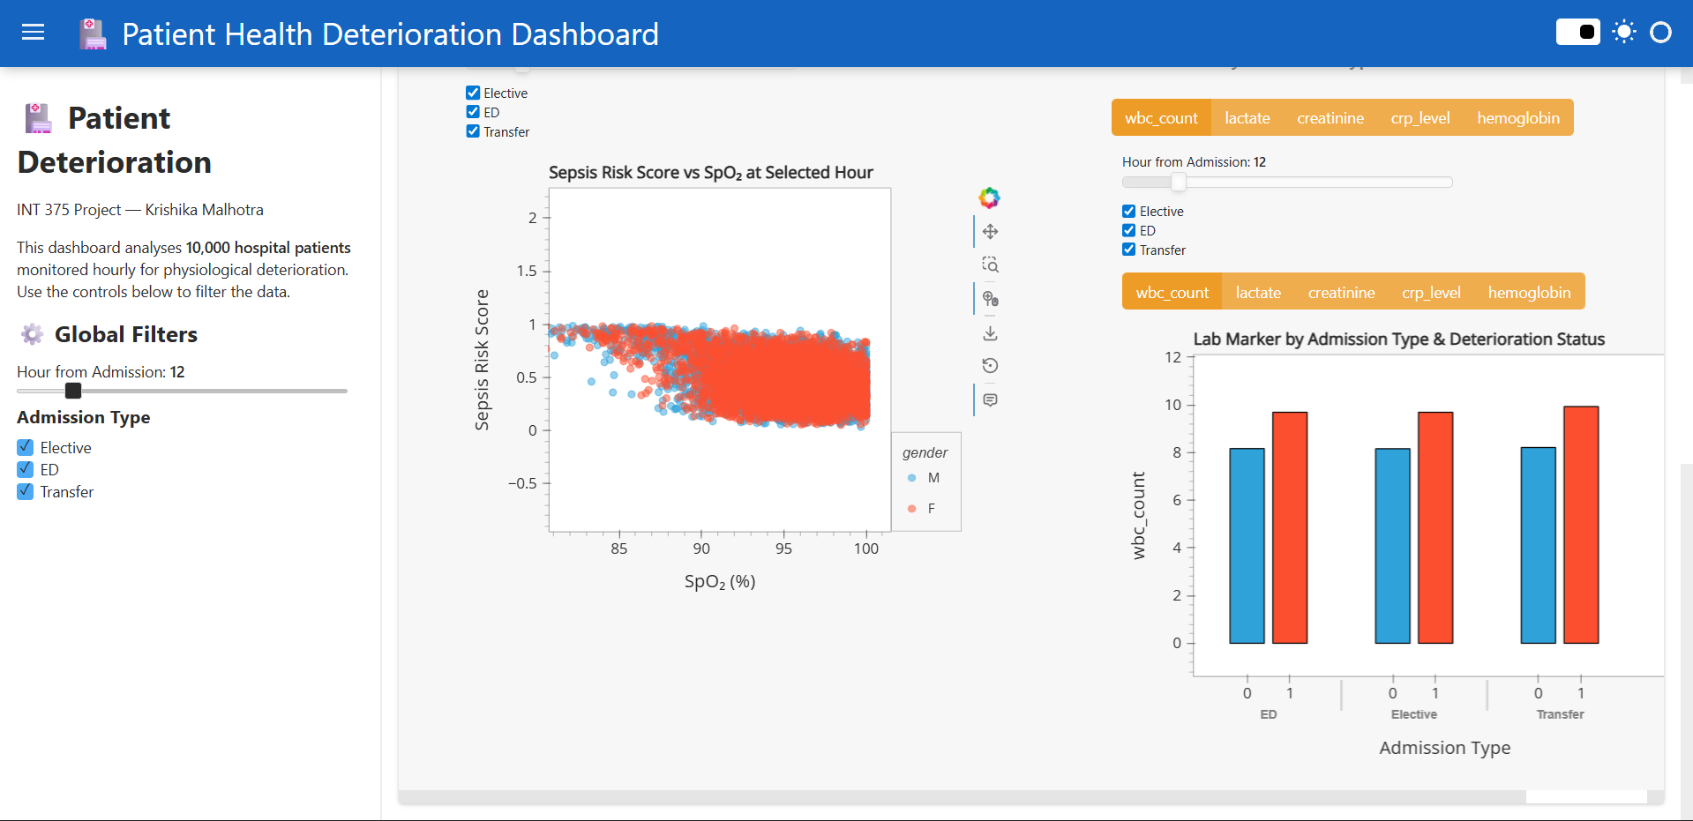

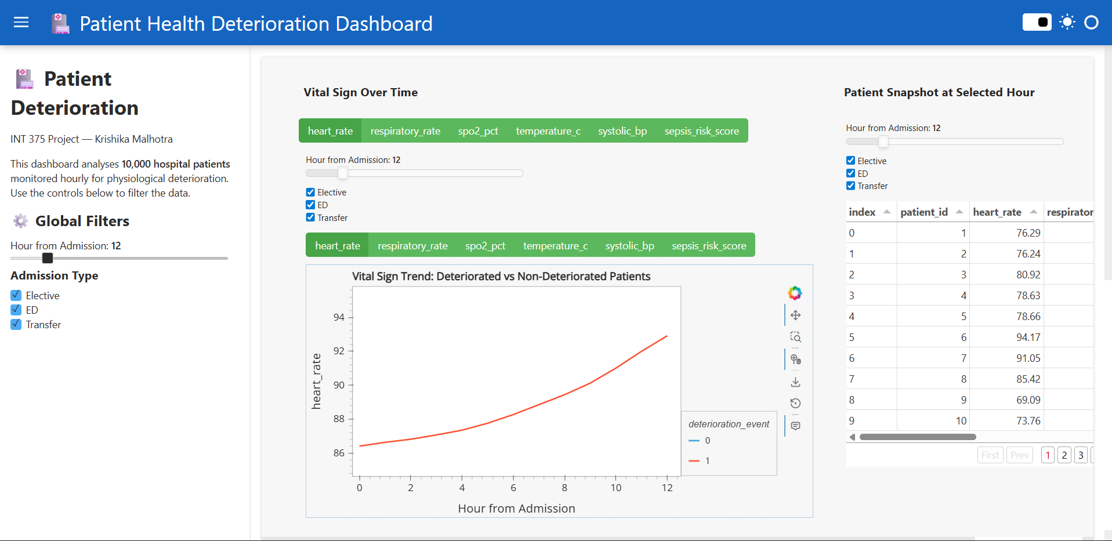

8.1 Time-Based Analysis of Vital Signs
One of the primary aspects of the analysis involves studying how vital signs change over time using the variable hour_from_admission. Time-based analysis is crucial in healthcare because patient conditions are dynamic and can change rapidly.

Line plots were used to visualize trends in key variables such as heart rate and oxygen saturation. These graphs help in identifying fluctuations, gradual increases or decreases, and sudden spikes in values.

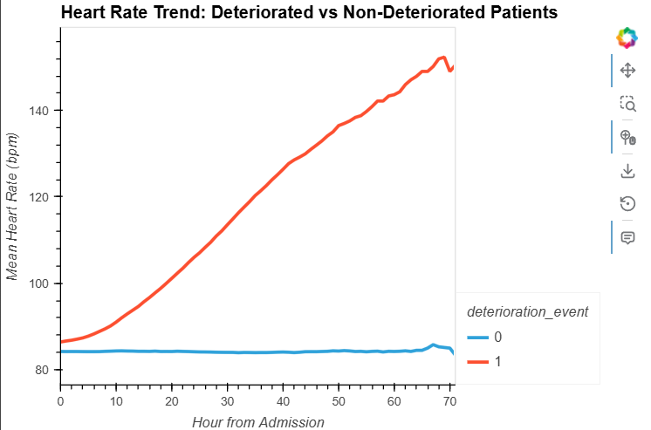

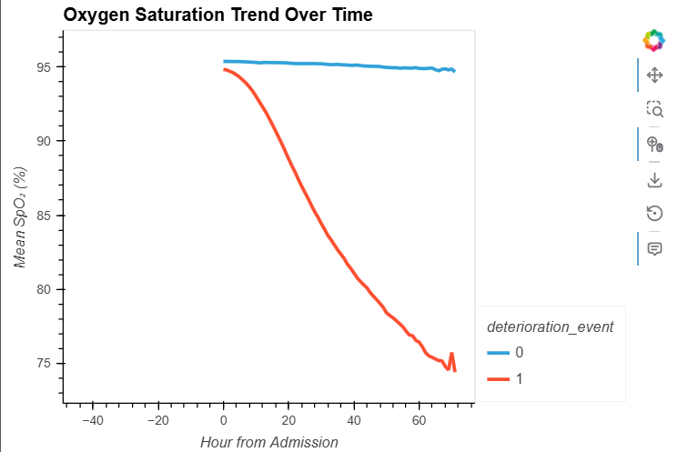

Interpretation:
The analysis shows that vital signs do not remain constant and exhibit fluctuations over time. In some cases, sudden changes in values may indicate potential deterioration or instability in patient condition.

8.2 Distribution Analysis of Health Metrics
To understand the overall behavior of different variables, distribution analysis was performed using histograms. This helps in identifying how frequently certain values occur and whether the data is evenly distributed.

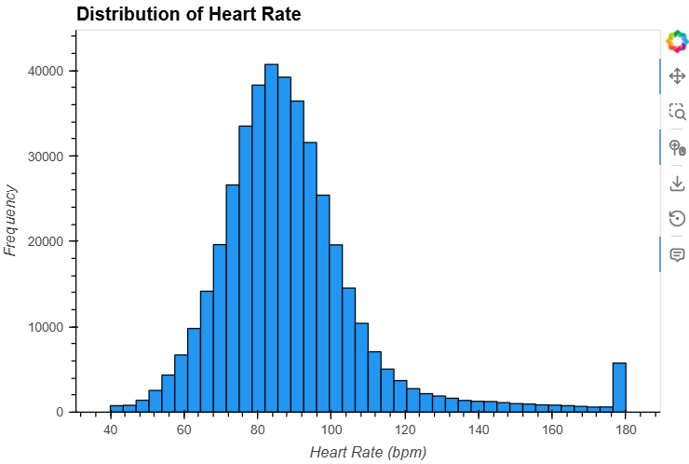

Interpretation:
Most values are concentrated within a specific range, indicating normal conditions, while extreme values represent abnormal or critical situations.

8.3 Outlier Detection and Variability
Boxplots were used to identify outliers and study the spread of data. Outliers represent unusual values that deviate significantly from the majority of observations and may indicate critical health conditions or measurement errors.

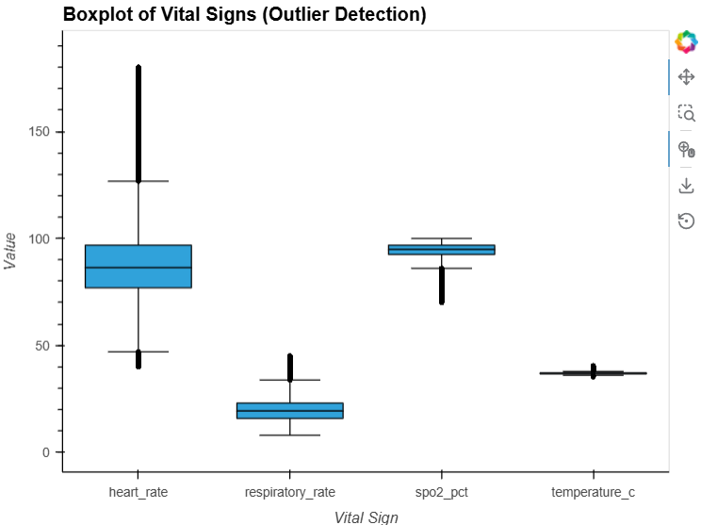
Interpretation:
The presence of outliers suggests that certain patients experience extreme variations in health metrics, which may require immediate medical attention.

8.4 Correlation Analysis
Correlation analysis was conducted to examine the relationships between different health indicators. A heatmap was used to visualize these relationships.

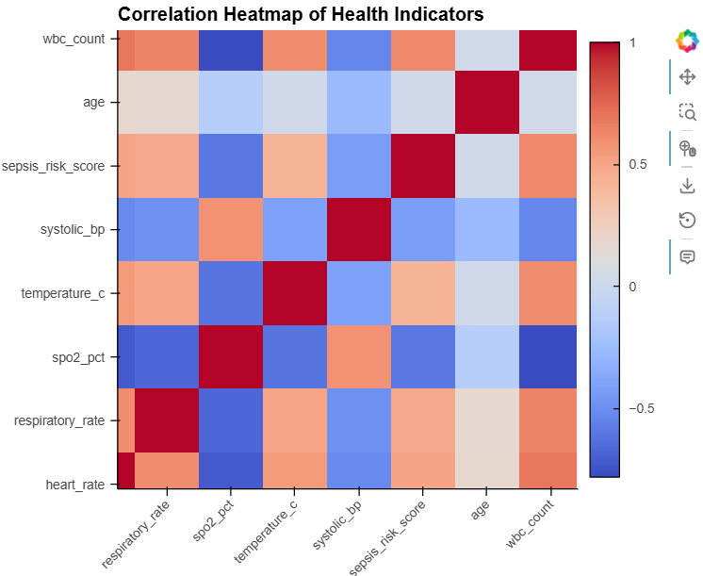

Interpretation:
The heatmap reveals that certain variables are related to each other, indicating that changes in one parameter may influence others. Understanding these relationships is important for identifying combined effects on patient health.

8.5 Analysis of Deterioration Events
A key focus of the analysis was the study of the deterioration_event variable. This variable indicates whether a patient’s condition worsened during the observation period.

By comparing vital signs during normal conditions and deterioration events, it becomes possible to identify patterns associated with declining health.

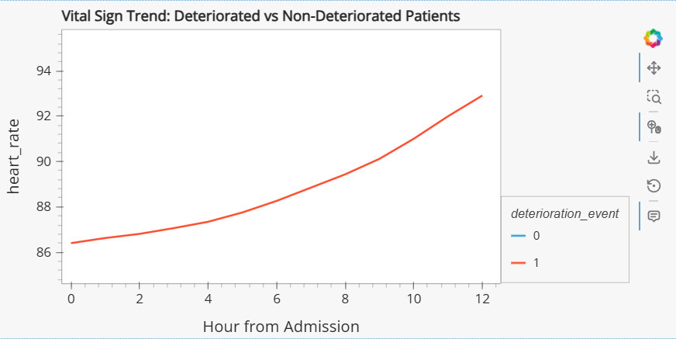

Interpretation:
Patients experiencing deterioration events often show abnormal patterns in vital signs, such as higher variability or extreme values.

8.6 Comparative Analysis of Variables
Comparative analysis was performed to examine differences between various health metrics. This helps in understanding how different variables behave under different conditions.

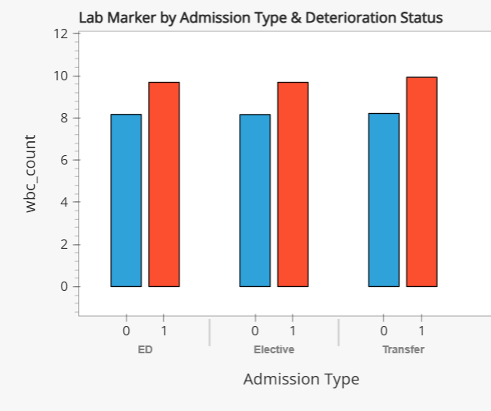

Interpretation:
Different health indicators exhibit varying levels of stability and fluctuation, highlighting the complexity of patient health dynamics.

8.7 Summary of Analysis
The analysis of the dataset provides several important insights into patient health and deterioration patterns:
- Vital signs vary significantly over time
- Certain variables show strong relationships with each other
- Outliers indicate abnormal or critical conditions
- Deterioration events are associated with noticeable changes in health metrics
These findings demonstrate the importance of continuous monitoring and data analysis in healthcare systems.

8.8 Importance of Analysis
The insights obtained from this analysis can be used to improve patient monitoring systems and support early detection of health risks. By identifying patterns and trends in patient data, healthcare professionals can take proactive measures to prevent deterioration and improve patient outcomes.
In conclusion, the analysis section highlights how data science techniques can be effectively applied to healthcare data to derive meaningful insights and support better decision-making.

RESULTS AND FINDINGS

The analysis of the patient health dataset led to several significant findings that provide valuable insights into the behavior of vital signs and their relationship with patient deterioration. By applying exploratory data analysis techniques and visualization methods, meaningful patterns were identified across multiple health indicators, highlighting the importance of continuous monitoring and data-driven decision-making in healthcare systems.

One of the key findings of the analysis is the presence of noticeable variability in patient vital signs over time. Parameters such as heart rate, respiratory rate, and oxygen saturation do not remain constant and exhibit fluctuations throughout the duration of hospital admission. These variations indicate that patient conditions are dynamic and require continuous observation rather than periodic checks. The time-based analysis revealed that certain patients show gradual changes in their vital signs, which may serve as early indicators of deterioration.

Another important observation is the identification of abnormal values and outliers within the dataset. The use of boxplots and distribution analysis helped in detecting extreme values that deviate significantly from the normal range. These outliers are critical as they may represent severe medical conditions or sudden changes in patient health. The presence of such anomalies emphasizes the need for robust monitoring systems that can quickly identify and respond to unusual patterns.

The correlation analysis provided insights into the relationships between different health indicators. It was observed that certain variables exhibit interdependencies, suggesting that changes in one parameter may influence others. For example, variations in heart rate may be associated with changes in respiratory rate or oxygen levels. Understanding these relationships is essential for developing a comprehensive view of patient health and identifying combined effects that may not be apparent when analyzing variables individually.

A major focus of the analysis was the study of deterioration events. By examining the deterioration_event variable, it was found that patients who experienced deterioration often showed distinct patterns in their vital signs. These patterns included increased variability, sudden spikes or drops, and deviations from normal ranges. This finding highlights the potential of data analysis in identifying early warning signs of deterioration, which can support timely medical intervention.

The distribution analysis further revealed that most values of health metrics fall within a specific range, indicating normal conditions for the majority of observations. However, the presence of extreme values indicates that certain cases require special attention. This uneven distribution underscores the importance of analyzing both common and rare occurrences in healthcare data.

Additionally, the analysis demonstrated the effectiveness of visualization techniques in interpreting complex datasets. Graphical representations such as line plots, histograms, and heatmaps made it easier to identify trends, patterns, and anomalies. These visual tools play a crucial role in simplifying data interpretation and enhancing the overall understanding of the dataset.

Overall, the findings of this project emphasize the importance of using data science techniques in healthcare analysis. By transforming raw data into meaningful insights, it becomes possible to improve patient monitoring systems, detect early signs of deterioration, and support better clinical decision-making. The results highlight the potential of data-driven approaches in enhancing healthcare outcomes and improving patient safety.

CONCLUSION

The analysis of patient health data conducted in this project demonstrates the significant role that data science can play in improving healthcare systems and patient outcomes. By utilizing Python-based tools and techniques, the project successfully transformed raw healthcare data into meaningful insights that provide a deeper understanding of patient conditions and deterioration patterns.

The study began with the extraction and preprocessing of the dataset, ensuring that the data was clean, consistent, and suitable for analysis. The ETL process played a crucial role in handling missing values, removing duplicates, and organizing the data in a structured manner. This step laid a strong foundation for accurate and reliable analysis.

Through exploratory data analysis, various patterns and trends were identified in patient vital signs. The time-based analysis highlighted the dynamic nature of patient health, showing that vital parameters such as heart rate and oxygen saturation change continuously over time. These fluctuations emphasize the need for continuous monitoring rather than relying on isolated measurements.

The identification of outliers and abnormal values further demonstrated the presence of critical conditions within the dataset. Such values are important indicators of potential health risks and require immediate attention. The ability to detect these anomalies through data analysis highlights the importance of using advanced analytical tools in healthcare.

Correlation analysis provided valuable insights into the relationships between different health indicators. Understanding these relationships is essential for gaining a holistic view of patient health and identifying combined effects that may contribute to deterioration. This multi-variable analysis represents a significant improvement over traditional methods that consider parameters in isolation.

The analysis of deterioration events was a key aspect of the project, revealing distinct patterns associated with declining patient conditions. These findings suggest that data-driven approaches can be used to identify early warning signs and support proactive medical interventions. By detecting deterioration at an early stage, it becomes possible to improve patient outcomes and reduce the risk of severe complications.

Furthermore, the use of visualization techniques played a vital role in presenting the data in an intuitive and interpretable manner. Graphs and charts helped in simplifying complex information and making it easier to identify patterns and trends. This highlights the importance of visual analytics in data science.

In conclusion, this project successfully demonstrates how data science techniques can be applied to healthcare data to derive meaningful insights and support better decision-making. It emphasizes the importance of continuous monitoring, data analysis, and visualization in improving patient care. The knowledge and skills gained through this project can be extended to more advanced applications such as predictive modeling, real-time monitoring systems, and intelligent healthcare solutions.

Overall, the project serves as a strong example of how data-driven approaches can enhance the efficiency and effectiveness of healthcare systems, ultimately contributing to improved patient safety and outcomes.

FUTURE SCOPE

While this project provides a comprehensive analysis of patient health data using exploratory data analysis techniques, there are several opportunities for further enhancement and expansion. The current study focuses primarily on descriptive and visual analysis; however, future work can extend this foundation to more advanced and practical applications in the healthcare domain.

One of the key areas for future development is the implementation of advanced machine learning models for predictive analysis. Techniques such as logistic regression, decision trees, random forests, and neural networks can be used to predict patient deterioration based on historical data. These models can help in identifying high-risk patients and enabling early intervention.

Another important direction is the integration of real-time data processing systems. In modern healthcare environments, patient data is continuously generated through monitoring devices. By integrating real-time data streams with analytical models, it becomes possible to develop systems that provide instant insights and alerts, improving the responsiveness of healthcare services.

The development of interactive dashboards is another potential area of enhancement. Tools such as Plotly, Dash, or Power BI can be used to create dynamic and user-friendly interfaces that allow healthcare professionals to explore data visually and interactively. Such dashboards can improve data accessibility and support better decision-making.

Additionally, incorporating more variables such as patient demographics, medical history, and environmental factors can provide a more comprehensive analysis. This would enable a deeper understanding of the factors influencing patient health and improve the accuracy of predictive models.
Geospatial analysis can also be integrated to study patterns across different regions or healthcare facilities. This can help in identifying location-based trends and improving resource allocation.

Furthermore, future work can focus on developing automated data cleaning and preprocessing pipelines to handle large datasets more efficiently. Automation can reduce manual effort and improve the scalability of the system.

In conclusion, the project provides a strong foundation for future research and development in healthcare analytics. By incorporating advanced techniques and expanding the scope of analysis, it is possible to create intelligent systems that not only analyze but also predict and prevent patient deterioration, thereby significantly improving healthcare outcomes.

REFERENCES

[1] Python Software Foundation, Python Documentation. [Online]. Available: https://www.python.org/doc/

[2] W. McKinney, pandas: Powerful Python Data Analysis Toolkit. [Online]. Available: https://pandas.pydata.org/docs/

[3] J. D. Hunter, "Matplotlib: A 2D Graphics Environment," Computing in Science & Engineering, vol. 9, no. 3, pp. 90–95, 2007.

[4] M. L. Waskom, "seaborn: statistical data visualization," Journal of Open Source Software, vol. 6, no. 60, p. 3021, 2021. doi: 10.21105/joss.03021.

[5] T. Hastie, R. Tibshirani, and J. Friedman, The Elements of Statistical Learning: Data Mining, Inference, and Prediction, 2nd ed. New York, NY, USA: Springer, 2009.

[6] World Health Organization, Air Quality and Health. [Online]. Available: https://www.who.int/

[7] Centers for Disease Control and Prevention, Healthcare Data and Statistics. [Online]. Available: https://www.cdc.gov/

[8] J. Brownlee, Machine Learning Mastery With Python: Understand Your Data, Create Accurate Models and Work Projects End-to-End. Machine Learning Mastery, 2016.

BIBLIOGRAPHY

[1] W. McKinney, Python for Data Analysis: Data Wrangling with Pandas, NumPy, and IPython, 2nd ed. Sebastopol, CA, USA: O'Reilly Media, 2017.

[2] J. VanderPlas, Python Data Science Handbook: Essential Tools for Working with Data. Sebastopol, CA, USA: O'Reilly Media, 2016.

[3] A. Géron, Hands-On Machine Learning with Scikit-Learn, Keras, and TensorFlow: Concepts, Tools, and Techniques to Build Intelligent Systems, 2nd ed. Sebastopol, CA, USA: O'Reilly Media, 2019.

[4] T. Hastie, R. Tibshirani, and J. Friedman, The Elements of Statistical Learning: Data Mining, Inference, and Prediction, 2nd ed. New York, NY, USA: Springer, 2009.

[5] I. Goodfellow, Y. Bengio, and A. Courville, Deep Learning. Cambridge, MA, USA: MIT Press, 2016.

[6] Center for Disease Control and Prevention, Public Health and Data Analytics Resources. Available: https://www.cdc.gov/

[7] Python Software Foundation, Python Documentation. [Online]. Available: https://www.python.org/doc/ [Accessed: Apr. 23, 2026]; W. McKinney, pandas Documentation.

DRIVE LINK : https://drive.google.com/drive/folders/1Joty0Q-egG0TLj6GKu2-8MwoYuvRBTht?usp=drive_link

LINKEDIN POST LINK : https://www.linkedin.com/posts/krishika-malhotra-b11297333_python-dashboard-datavisualization-ugcPost-7453138481117151232-dKhj?utm_source=share&utm_medium=member_desktop&rcm=ACoAAFPeln0B69BBh-KBEmF9L9Ym6uqQ8nShqEU

